**KeepAliveServerUniversal**

**Spec. Version 0.01**

Keep Alive Server Universal – the websocket server that helps track program activity and send messages to messengers channels/groups/rooms.

Supported messengers: Telegram, Matrix.

Constants:

Ip: <ip>; Port: <port>

Timeout – 60 seconds – period of the last activity (last ping time or send message time) of the client, which exceedance result to disconnection of session with the client.

Connection string: **ws://<ip>:<port>/ws**

**Authentification**

After connecting to a websocket server, client needs to send authentification message, template which differs to a type of messenger.

Telegram:

{"messengerType": "telegram","scriptName": "<name_of_the_programm>","loginInfo": {"botID": "<your_bot_id>","chatID": "<your_chat_id>"}}

Matrix:

{"messengerType": "matrix","scriptName": "<name_of_the_programm>","loginInfo": {"federation": "<federation>","room": "<room_alias>:<federation2>","token": "<token>"}}

Federation – is domain of matrix server, i.e. “matrix.org”

Room – alias name of the room, can be set as: #<room_alias>:<federation2> or <room_alias>:<federation2>. Or you can emit <federation2>, for example #<room_alias> or <room_alias>. But in this case <federation2> will be setted as <federation> - from previous field.

*Detailed instruction for Matrix messenger is illustrated in Application 1*

**Authentification response**

After sending auth message, you’ll receive message: {"err": "<error_message>"}, where <error_message> - is empty string in case of successful authentification and isn’t empty and contains error message in case of unsuccessful authentification.

In case of successful authentification, server send’s “online” message to messenger:

2023-Feb-12 16:43:34UTC,KeepAliveServer: <name_of_the_programm> is online✅

**Ping**

After <Timeout> seconds of inactivity, server closed connection with client, so to provide connection alive, client needs to send ping message to server. Ping message is empty string.

**Sending message to messengers**

To send message to messenger, just send to websocket connection needed message, for example by sending to websocket message: “my_message”, server will send to messenger:

2023-Feb-12 16:43:57UTC,KeepAliveServer: Message from <name_of_the_programm>: my_message

**Close connection**

After closing connection (with previous successful authentification), server will send “offline” message to messenger:

2023-Feb-12 16:44:28UTC,KeepAliveServer: <name_of_the_programm> is offline❌ (no message in 60s)

*Application 1:*

*How to get room alias?*

For public rooms you can get room alias in room settings:

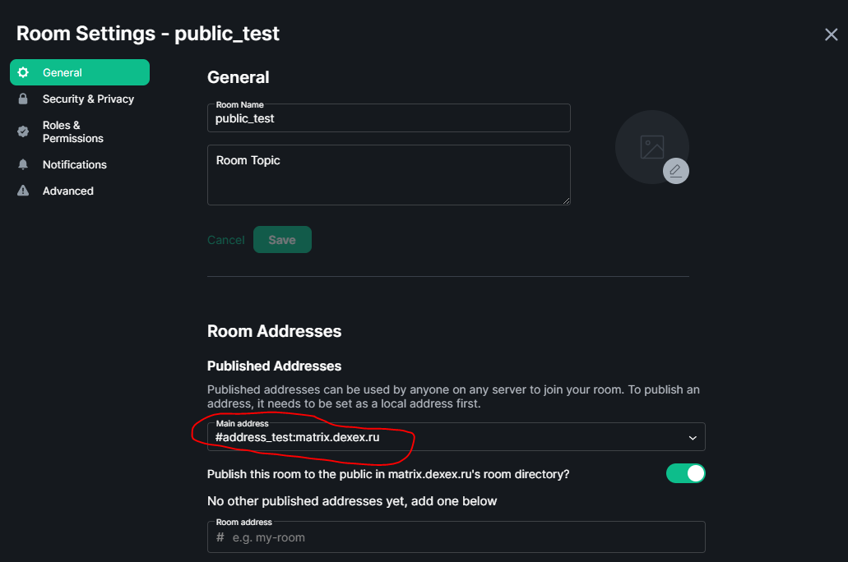For private room you should manually set room address (and click “Add”)

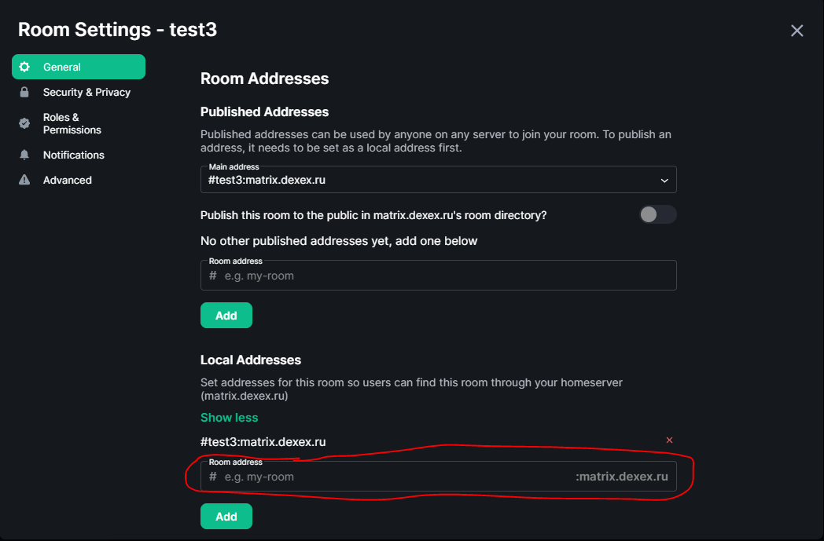**After setting room alias name, you should Invite your bot to this room!**

*How to get token?*

To get token, you need send POST request to url:

[https://<federation>/_matrix/client/r0/login](https://matrix.dexex.ru/_matrix/client/r0/login)

With the body:

{"type":"m.login.password", "user":"<your_bot_username>", "password":"<your_bot_password>"}

You’ll get response:

{"user_id": "<>","access_token": "<your_token>","home_server": "<...>","device_id": "<...>"}

So, <your_token> is your token.